Works available by Daniela Mejia
2 September 2024

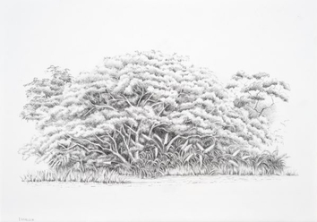 | Daniela Mejia  Pencil and Paper 3, 2024  Graphite on paper  23 x 32 cm  9 x 12 5/8 in
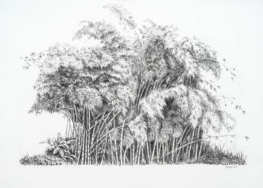 | Daniela Mejia  Pencil and Paper 2, 2024  Graphite on paper  23 x 32 cm  9 x 12 5/8 in
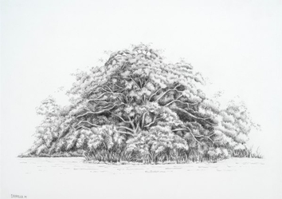 | Daniela Mejia  Pencil and Paper 1, 2024  Graphite on paper  23 x 32 cm  9 x 12 5/8 in
 | Daniela Mejia  Departing, 2024  Oil on board  25 x 35 cm  9 7/8 x 13 3/4 in
 | Daniela Mejia  Returning, 2024  Oil on board  25 x 35 cm  9 7/8 x 13 3/4 in
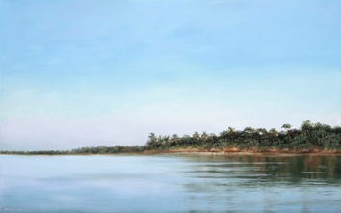 | Daniela Mejia  First Light, 2024  Oil on canvas  25 x 35 cm  9 7/8 x 13 3/4 in
 | Daniela Mejia  Shore, 2024  Oil on board  20 x 40 cm  7 7/8 x 15 3/4 in
 | Daniela Mejia  Sandy Mornings, 2024  Oil on canvas  36 x 75 cm  14 1/8 x 29 1/2 in
 | Daniela Mejia  Haze of Dust, 2024  Oil on canvas  44 x 90 x 2.5 cm  17 3/8 x 35 3/8 x 1 in
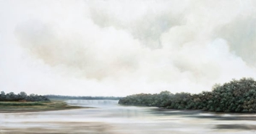 | Daniela Mejia  Gentle Glow, 2023  Oil on canvas  44 x 84 cm  17 3/8 x 33 1/8 in
 | Daniela Mejia  Red Shore, 2024  Oil on canvas  40 x 120 cm  15 3/4 x 47 1/4 in
 | Daniela Mejia  Sanctuary of the Sierra, 2023  Oil on canvas  45 x 110 cm  17 3/4 x 43 1/4 in
 | Daniela Mejia  Sanctuary, 2023  Oil on canvas  55 x 143 cm  21 5/8 x 56 1/4 in
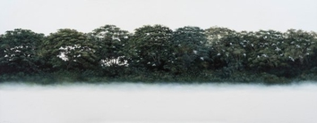 | Daniela Mejia  Breathe Green, 2024  Oil on canvas  55 x 140 cm  21 5/8 x 55 1/8 in
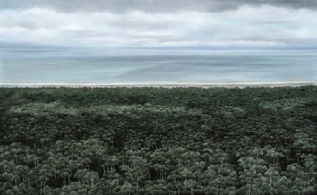 | Daniela Mejia  Border, 2024  Oil on canvas  80 x 130 cm  31 1/2 x 51 1/8 in
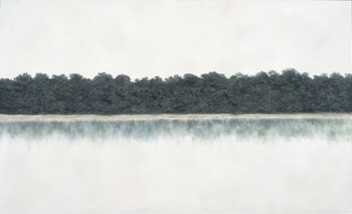 | Daniela Mejia  Lifeline 2, 2023  Oil on canvas  80 x 130 cm  31 1/2 x 51 1/8 in
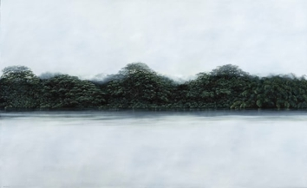 | Daniela Mejia  Lifeline, 2023  Oil on canvas  80 x 130 cm  31 1/2 x 51 1/8 in

